JAVA Assignment 1

Thanuja R (192325004)

1.Write a program to print all the composite numbers between a and b?

Sample Input:

A = 12

B = 19

Sample Output

14, 15, 16, 18

Test cases:

1. A = 11, B = 11

2. A = 20, B = 10

3. A = 0, B = 0

4. A = -5, B = 5

5. A = 7, B = -12

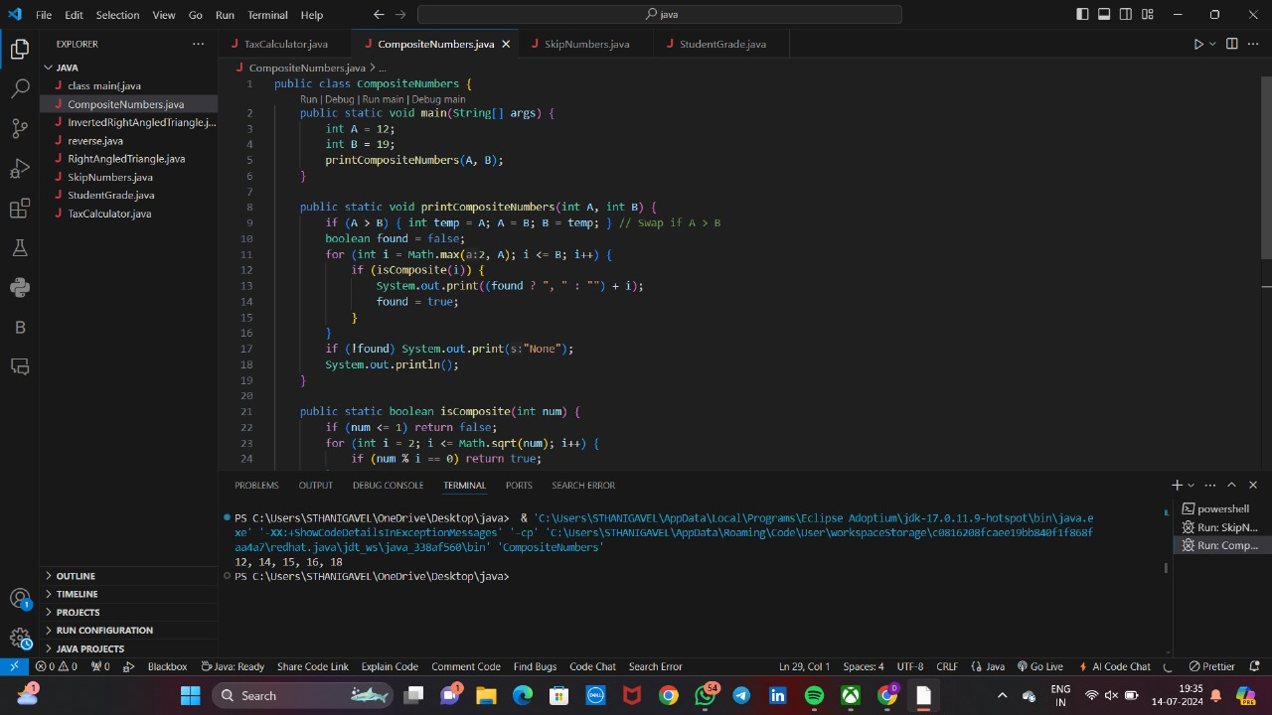

2.Write a program to print the numbers from M to N by skipping K numbers in between?

Sample Input:

M = 50

N = 100

K = 7

Sample Output:

50, 58, 66, 74, …..

Test cases:

1. M = 15, N = 05, K = 02

2. .M = 25, N = 50, K = 04

3. M = 15, N = 100, K = -02

4. M = 0 , N = 0 , K = 25. M = 200 , N = 200 , K = 50

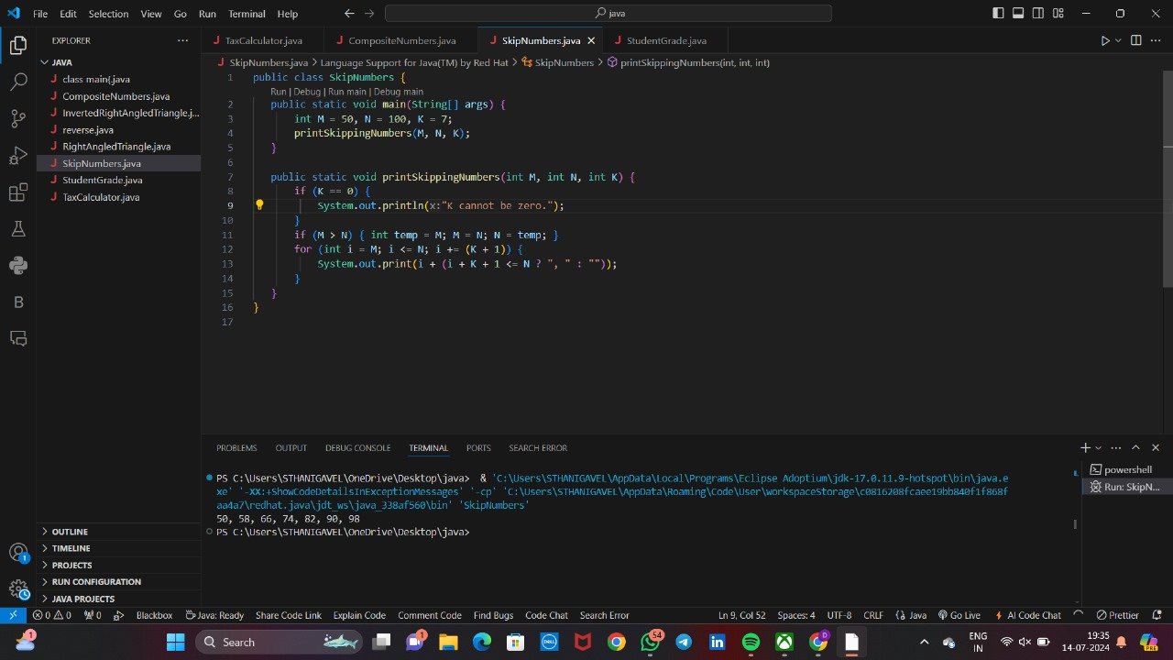

3.Write a program to enter the marks of a student in four subjects. Then calculate the total and aggregate, display the grade obtained by the student. If the student scores an aggregate greater than 75%, then the grade is Distinction. If aggregate is 60>= and <75, then the grade is First Division. If aggregate is 50 >= and <60, then the grade is Second Division. If aggregate is 40>= and <50, then the grade is Third Division. Else the grade is Fail.

Sample Input & Output:

Enter the marks in python: 90

Enter the marks in c programming: 91

Enter the marks in Mathematics: 92

Enter the marks in Physics: 93

Total= 366

Aggregate = 91.5

DISTINCTION

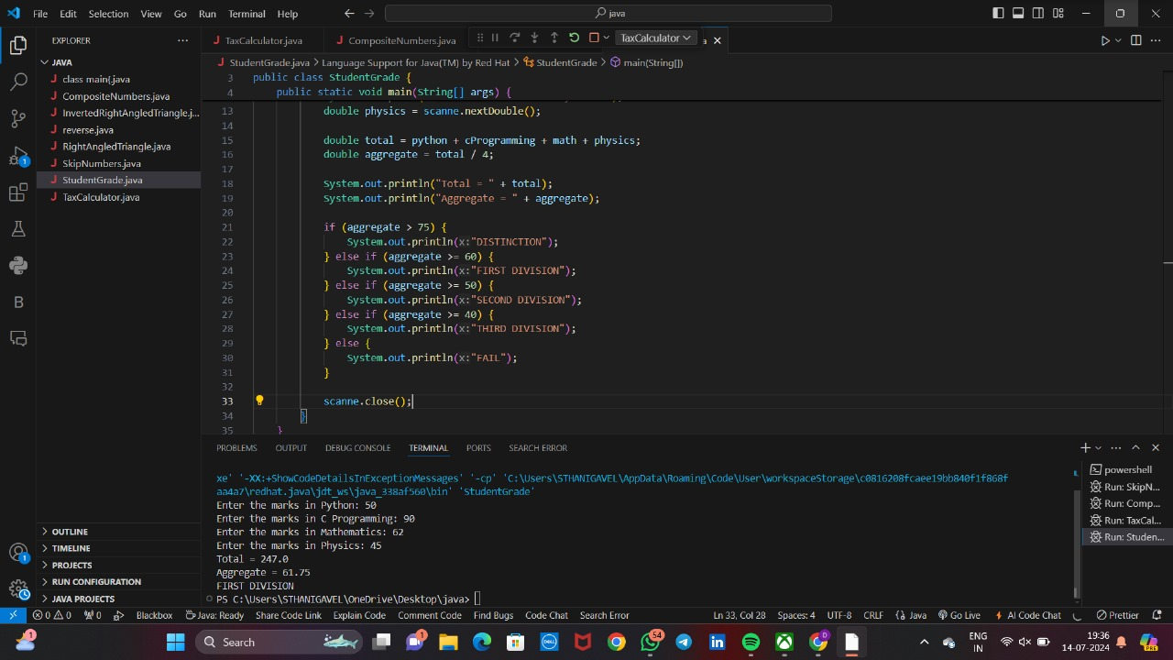

4.Write a program to calculate tax given the following conditions:

a. If income is less than or equal to 1,50,000 then no tax

b. If taxable income is 1,50,001 – 3,00,000 the charge 10% tax

c. If taxable income is 3,00,001 – 5,00,000 the charge 20% tax

d. If taxable income is above 5,00,001 then charge 30% tax

Sample Input:

Enter the income:200000

Sample Output:

Tax= 20000

